NATURAL CONVECTION FLOW UNDER A MAGNETIC FIELD IN AN INCLINED SQUARE ENCLOSURE DIFFERENTIALY HEATED ON ADJACENT WALLS

Mehmet Cem Ece & Elif Büyük
Department of Mechanical Engineering
Trakya University
22030 Edirne, Turkey.

Abstract: Steady, laminar, natural-convection flow in the presence of a magnetic field in an inclined square enclosure differentially heated along the bottom and left vertical walls while the other walls are kept isothermal was considered. The governing equations were solved numerically for the stream function, vorticity and temperature ratio using the differential quadrature method for various Grashof and Hartmann numbers, inclination angle of the enclosure and direction of the magnetic field. The orientation of the enclosure changes the temperature gradient inside and has a significant effect on the flow pattern. Magnetic field suppresses the convective flow and its direction also influences the flow pattern, causing the appearance of inner loops and multiple eddies. The surface heat flux along the bottom wall is slightly increased by clockwise inclination and reduced by half by the counterclockwise inclination. The surface heat flux along the upper portion of the left side wall is reversed by the rise of warmer fluids due to the convection currents for no inclination and clockwise inclination of the enclosure.

Keywords: Natural convection, magnetic field, inclined enclosure.

Nomenclature
a | Weight functions of the first order derivative
B | Magnetic field strength
b | Weight functions of the second order derivative
Gr | Grashof number
g | Gravitational acceleration
Ha | Hartmann number
L | Characteristic length
Nu | Nusselt number
Pr | Prandtl number
p | Pressure
Ra | Rayleigh number
T | Temperature
u | Velocity component in the x direction
v | Velocity component in the y direction
x | Cartesian coordinates
y | Cartesian coordinates

Greek
α | Thermal diffusivity of the fluid
β | Coefficient of thermal expansion of the fluid
η | Dimensionless coordinate normal to the enclosure wall
θ | Dimensionless temperature ratio
μ | Viscosity
ρ | Density of the fluid
σ | Electrical conductivity of the fluid
φ | Angle of inclination of the enclosure
ϕ | Angle of direction of the magnetic field with respect to the coordinate system
ψ | Dimensionless stream function
ω | Vorticity

Superscripts
* | Dimensional variable

Subscripts
0 | Ambient value

Introduction
Laminar natural-convection flows in enclosures are encountered in variety of engineering applications including cooling of electronic equipment, nuclear reactor insulation, solar energy collection, and crystal growth in liquids and a large number of investigations have focused on the subject [3, 5, 11, 15, 16, 18-20, 23-25]. Comprehensive reviews of the investigations on the subject are also given by .Catton [8], Yang [30], Fusegi and Hyun [13] and Bejan [4]. The Lorentz force is also active and interacts with the buoyancy force in governing the flow and temperature fields when the fluid is electrically conducting and also exposed to a magnetic field. Effect of the Lorentz force is known to reduce the velocities and therefore suppress the convection currents and it has increasing applications in material manufacturing industry as a control mechanism. Study and thorough understanding of the momentum and heat transfer in such a process is important for the better control and quality of the manufactured product.
The study of Oreper and Szekely [21] shows that the magnetic field suppresses the natural convection currents and the magnetic field strength is one of the most important factors for crystal formation. Ozoe and Maruo [22] numerically investigated the natural convection of a low Prandtl number fluid in the presence of a magnetic field and obtained correlations for the Nusselt number in terms of Rayleigh, Prandtl and Hartmann numbers. Garandet et al. [14] proposed an analytical solution to the governing equations of magnetohydrodynamics to be used to model the effect of a transverse magnetic field on natural convection in a two-dimensional cavity. Rudraiah et al. [26] numerically investigated the effect of a transverse magnetic field on natural-convection flow inside a rectangular enclosure with isothermal vertical walls and adiabatic horizontal walls and found out that a circulating flow is formed with a relatively weak magnetic field and that the convection is suppressed and the rate of convective heat transfer is decreased when the magnetic field strength increases. Alchaar et al. [1] numerically investigated the natural convection in a shallow cavity heated from below in the presence of an inclined magnetic field and showed that the convection modes inside the cavity strongly depend on both the strength and orientation of the magnetic field and that horizontally applied magnetic field is the most effective in suppressing the convection currents. Al-Najem et al. [2] used the power law control volume approach to determine the flow and temperature fields under a transverse magnetic field in a tilted square enclosure with isothermal vertical walls and adiabatic horizontal walls at Prandtl number of 0.71 and showed that the suppression effect of the magnetic field on convection currents and heat transfer is more significant for low inclination angles and high Grashof numbers.
The previous studies of the laminar natural-convection flows in the presence of a magnetic field in enclosures have dealt with thermal boundary conditions involving mostly isothermal vertical walls and adiabatic horizontal walls and a transverse magnetic field. The present study considers laminar natural-convection flows in the presence of a magnetic field of an arbitrary direction in an inclined square enclosure where the temperatures of the heated bottom and left vertical walls vary linearly from a high value at the intersection point to a low value at the corners of the isothermal cold walls. The complex interaction of the flow and temperature fields in a finite-size inclined enclosure is an intriguing subject faced by engineers. The boundary conditions considered have a practical importance in applications involving differentially heated non-isothermal walls. The strong convection currents may alter the magnitude and direction of the wall heat flux, carrying warmer fluid particles to the regions near the relatively colder parts of the heated wall. The object of the study is to obtain numerical solutions for the velocity and temperature fields inside the enclosure and to determine the effects of the strength and orientation of the magnetic field and the inclination of the enclosure on the transport phenomena.

Basic equations
Steady, laminar, natural-convection flow in the presence of a magnetic field in an inclined square enclosure was considered. Dimensional coordinates with the x*-axis measuring along the bottom wall and y*-axis being normal to it along the left wall were used. The geometry and the coordinate system are schematically shown in Fig.1. The angle of inclination of the enclosure from horizontal in the counterclockwise direction is denoted by φ. Magnetic field of strength B is applied at an angle ϕ with respect to the coordinate system. The top and right vertical walls are kept at a constant temperature T₀ while the temperature along the bottom and left vertical walls varies linearly from T₀ at one end to T₁ at the lower left corner where they meet.
Dimensionless variables used in the analysis were defined according to,
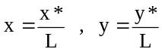 , (1)
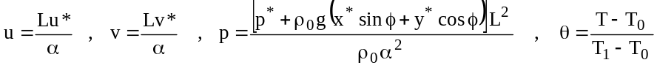 . (2)
Here L is the dimensional length of the square enclosure, u* and v* are the dimensional velocity components in the x* and y* directions respectively, p* is the dimensional pressure, ρ₀ is the density of the fluid at temperature T₀ and α is the thermal diffusivity of the fluid. The magnetic Reynolds number was assumed to be small and the induced magnetic field due to the motion of the electrically conducting fluid was neglected. The Joule heating of the fluid and the effect of viscous dissipation were also considered to be negligible.
A dimensionless stream function and vorticity were defined as follows,
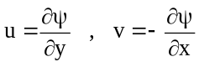 , (3)
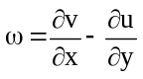 . (4)

The governing equations under Boussinesq approximation in terms of the dimensionless variables may then be written as
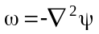 , (5)
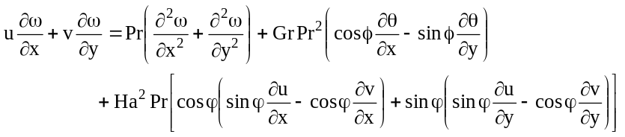 , (6)
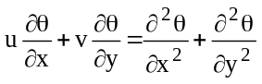 . (7)
Here the Prandtl, Grashof and Hartmann numbers are defined as follows
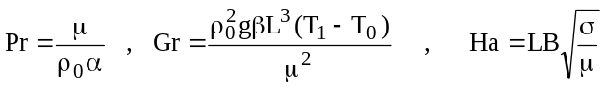 , (8)
where μ is the viscosity, β is the coefficient of thermal expansion and σ is the electrical conductivity of the fluid respectively. Boundary conditions are
, (9)
, (10)
. (11)
The boundary condition given by Eqs. (9) and (10) may also be expressed in terms of the stream function.
, (12)
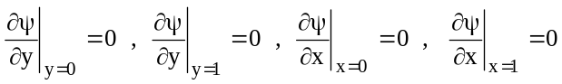 . (13)

Numerical scheme
The dimensionless governing equations were solved for stream function, vorticity and temperature ratio using the differential quadrature method originally proposed by Bellman et al. [6, 7]. The basis of the method is to assume that the unknown functions can be locally approximated as polynomials. The first and second order partial derivatives of a two-variable function F(x,y) at a point (x_{i},y_{j}) can be approximated as
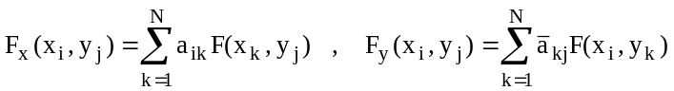 , (14)
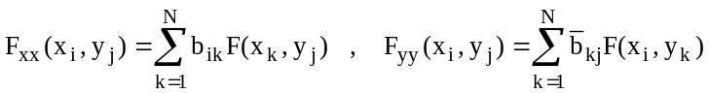 . (15)
Here (N-1) is the degree of the polynomial behavior assumed and the weight functions are given by Shu and Richards [27, 28] and Shu [29] as follows

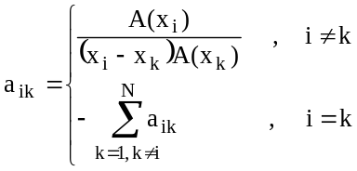 , (16)

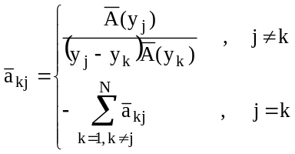 , (17)

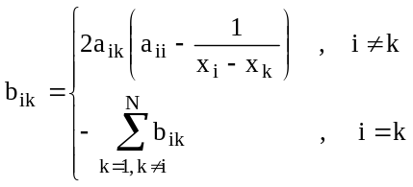 , (18)

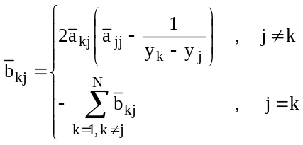 , (19)

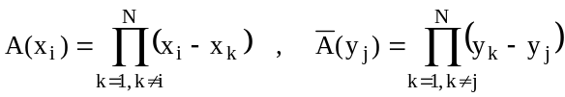 . (20)

The stream function, vorticity and temperature ratio were assumed to behave as polynomials of 4th degree in both x and y directions and N=5 was used. Numerical mesh size h=0.01 was used in both directions to insure a good accuracy. The velocity components at each mesh point were determined by differentiating the stream function using the expressions for the first order derivatives given by Eq. (14) at each stage of the iterations. Vorticity on the walls of the enclosure was determined according to
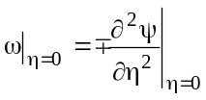 , (21)
where η is the normal coordinate measured away from the wall and the differentiation was carried out using the expressions for the second order derivatives given by Eq. (15). Iterations were stopped when the absolute values of the difference between the successive solutions for stream function, vorticity and temperature ratio at each mesh point are less than 10⁻⁶.
Results
Numerical computations in the present study were carried out for Pr=1 which is an approximate value for most gases. The inclination angle of the enclosure was chosen as -45°, 0° and 45°. The vorticity equation clearly indicates that magnitudes of Grashof and Hartmann numbers are important in making either the buoyancy or the magnetic force dominant on the flow field inside the enclosure. The both forces are equally effective when Gr/Ha² = O(1). The buoyancy is dominant as long as O(Gr/Ha²) >> 1 and the magnetic field is dominant when O(Gr/Ha²) << 1. The Hartmann number was taken in the range 0-100 and the angle of orientation of the magnetic field was taken as 0°, 45° and 90°. The Grashof number was taken in the range 10⁴-10⁶, but in some cases associated with lower values of the Hartmann number, the convergence of the numerical iterations could not be obtained above the Grashof number of 10⁵.
The fact that the interaction of the main circulation eddy with the side walls in a differentially heated enclosure should give rise to a secondary flow with a velocity component parallel to the eddy axis was first pointed out by Davis [10] and experimentally confirmed by Hiller et al [17]. However, the study of Di Piazza and Ciofalo [12] shows that three-dimensionality is almost completely suppressed by the interactions of magnetohyrodynamic body force. For these reasons, two-dimensional flow and temperature fields were considered in the present study.
Streamlines and isotherms for Ha=0 and various enclosure inclination and Grashof numbers are shown in Fig. 2 and 3 respectively. It may be observed that the streamlines form an almost centrally located eddy with clockwise rotation for φ=0°. Fluid particles heated near the hot walls are carried upward along the left side wall and the cold fluid particles are pulled downward along the right side wall to replace them. As the Grashof number increases, convection becomes more dominant and therefore the circulation becomes stronger. The warm fluid particles rise at a faster rate near the left side wall, thus uplifting the isotherms. Strong circulation also carries the colder fluid particles farther along the bottom wall and compresses the isotherms toward the left side wall as a result. The center of the enclosure is filled with relatively cold fluid. The surface heat flux is increased along the bottom wall and the lower portion of the left side wall. But the direction of the heat flow is reversed along the upper portion of the left side wall due the circulated warm fluid particles with temperatures exceeding the surface temperature in that region. The adjacent hot walls are both inclined from the vertical with a 45° angle for φ=-45°. The temperature gradient is somewhat reduced in this case since the hot wall face each other in the direction of gravity. The streamlines are also in the form of a clockwise-rotating single eddy but with a weaker circulation due to the reduced temperature gradient. As the Grashof number and hence the circulation increase, the streamlines are slightly compressed toward the horizontal diagonal connecting the hot and cold corners. Although the temperature field displays a pattern similar to the previous case, the distortion of the isotherms is slightly less intense. The surface heat flux is enhanced along the bottom wall and lower portion of the left side wall. Streamlines are in the form of two counter rotating eddies for φ=45° since two adjacent hot walls are both inclined symmetrically from the horizontal with a 45° angle facing upward to the cold walls in this case. Fluid particles heated near the hot walls are carried upward along the vertical diagonal and the cold fluid particles are brought downward along the side walls to replace them. Circulation of the eddies become stronger enhancing the convection as the Grashof number increases and the isotherms are uplifted along the vertical diagonal and drawn along the horizontal diagonal from the side corners. The surface heat flux therefore is enhanced by circulation near the outer portions of the hot walls.
Streamlines and isotherms for the magnetic field applied along the x-axis (ϕ=0°) with Ha=100 and various enclosure inclination and Grashof numbers are shown in Fig. 4 and 5 respectively. The circulation is observed to be weaker in these cases as compared to the corresponding previous cases where Ha=0 since the magnetic field considerably retards the convection currents. The flow field is consist of a clockwise-rotating single eddy when the enclosure is not inclined (φ=0°) and 45° clockwise inclined (φ=-45°) for moderate Grashof numbers. When the magnetic field is applied along the x-axis (ϕ=0°), the magnetohyrodynamic body force acts along the y-axis and works to retard the fluid particles carried upward along the hot side wall and to accelerate the cold fluid particles brought down along the cold side wall. Therefore the center of the eddy is closer to the bottom wall in this case. The circulation and vorticity become stronger as the Grashof number increases and finally a second eddy with counterclockwise rotation forms near the upper left corner of the enclosure when φ=0°. The isotherms resemble the heat transfer by pure conduction for values of the Grashof number up to 10⁵. Convection becomes dominant for higher values of the Grashof number and the isotherms are both uplifted and expanded toward the right side when φ=0°. Streamlines are in the form of two counter rotating eddies for values of the Grashof number up to 10⁵ in the case φ=45°. The attachment points of the dividing streamline are observed to shift from the upper and lower corners toward right and left respectively due to the presence of the magnetic field since the magnetohyrodynamic body force breaks the symmetry. Fluid particles heated near the hot walls are carried upward along the dividing streamline and the circulation of the eddies becomes stronger enhancing the convection as the Grashof number increases and the isotherms are slightly uplifted along the vertical diagonal. The eddy on the left is observed to grow substantially enclosing two inner loops and the eddy on the right is intensely compressed toward the lower right wall when Gr=10⁶. A small eddy also emerges near the upper right wall. It should be noted that the dividing streamline is almost parallel to the lower right wall in this case. The isotherms are lifted along the dividing streamline and compressed toward the upper right wall due to the strong circulation of counter rotating eddy pair. The surface heat flux is enhanced by circulation along the hot walls.
Streamlines and isotherms for the magnetic field applied along the y-axis (ϕ=90°) with Ha=100 and various enclosure inclination and Grashof numbers are shown in Fig. 6 and 7 respectively. The magnetohyrodynamic body force acts along the x-axis and works to retard the fluid particles carried in the direction of positive x-axis and to accelerate those moving in the direction of negative x-axis. The circulation is weaker in these cases too as compared to the corresponding previous cases where Ha=0 due to the retarding effect of the magnetic field on the convection currents. It may be observed that the streamlines form a clockwise rotating eddy for φ=0°. The circulation is very weak for Gr=10⁴ and the eddy encloses two small inner loops at the center. The circulation and vorticity become stronger as the Grashof number increases and the center of the eddy moves closer to the left side wall with the loop on the right almost diminishing. A second eddy with counterclockwise rotation forms near the upper left corner for Gr=10⁶. The isotherms resemble the heat transfer by pure conduction for values of the Grashof number up to 10⁵ and are slightly expanded toward the upper right corner. The strong circulation draws and compresses the isotherms intensely toward the top wall for Gr=10⁶. The surface heat flux is increased along the bottom wall and reversed along the upper portion of the left side wall. The streamlines are also in the form of a clockwise rotating single eddy with the center near the upper left wall for φ=-45°. Circulation is much stronger as compared to the case of no inclination as implied by the values of the streamlines. The center of the eddy is closet to the left side wall due to the act of the magnetohyrodynamic body force. The streamlines are displaced away from the upper portion of the left side wall when Gr=10⁶ heralding the possible formation of a secondary eddy near this corner. The isotherms are considerably expanded toward the upper right wall by the strong circulation as the Grashof number increases. The surface heat flux is reversed along the upper portion of the left side wall. Streamlines display two counter-rotating eddies for the case φ=45°. The dividing streamline is observed to rotate in the clockwise direction with the attachment points shifting from the upper and lower corners toward left and right respectively since the magnetohydrodynamic body force breaks the symmetry. The eddy on the right is observed to grow substantially enclosing two inner loops and the eddy on the right is intensely compressed toward the lower left wall when Gr=10⁶. It should be noted that the dividing streamline is almost parallel to the lower left wall in this case. The isotherms are lifted along the dividing streamline and compressed toward the upper left wall due to the strong circulation of counter rotating eddy pair. The surface heat flux substantially decreases near the attachment point of the dividing streamline on the right hot wall and it is enhanced along the left hot wall.
Streamlines and isotherms for the magnetic field applied diagonally (ϕ=45°) with Ha=100 and various enclosure inclination and Grashof numbers are shown in Fig. 8 and 9 respectively. The circulation is also weaker than the corresponding cases where Ha=0 due to the retarding effect of the magnetic field on the convection currents. The magnetohyrodynamic body force acts along both the x- and y-axes in this case. It may be observed that a clockwise rotating eddy is formed with the streamlines compressed toward the right diagonal for φ=0°. The circulation and vorticity become stronger as the Grashof number increases and the streamline are observed to be more compressed toward the diagonal in the upper domain for values of the Grashof number up to 10⁵. A group of three counter-rotating eddies emerges within the enclosure for Gr=10⁶. The isotherms resemble the heat transfer by pure conduction for Gr=10⁴ and are slightly expanded toward the top wall for Gr=10⁵. For higher values of the Grashof number the isotherms are strongly expanded along the diagonal due to the presence of counter-rotating eddies and strong circulation. A clockwise rotating eddy is also formed with the streamlines compressed toward the horizontal diagonal φ=-45°. The isotherms resemble the heat transfer by pure conduction for relatively small values of the Grashof number and are slightly expanded toward upper left wall for Gr=10⁵. The expansion of the isotherms toward the upper left wall is much more pronounced with the strong circulation for Gr=10⁶. Streamlines are in the form of two counter-rotating eddies for values of the Grashof number up to 10⁵ in the case φ=45° The centers of the eddies move closer to each other as the Grashof number increases and a second pair of counter-rotating eddies forms for Gr=10⁶. The isotherms are lifted upward slightly along the dividing streamline under the influence of two counter-rotating eddies for values of the Grashof number up to 10⁵. The isotherms are expanded toward the upper and lower left walls and depressed along the vertical diagonal due to the strong circulation of counter rotating eddy pairs and display a complex behavior.
The local Nusselt numbers in terms of the dimensionless variables are defined as follows
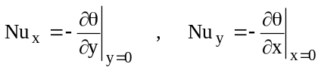 . (22)
Eqs. (14) were used in the evaluation of the derivatives in the present study. Variations of the local Nusselt number along the left side and bottom walls for various inclination angles are shown in Figs. 10 and 11 respectively for Gr=10⁵. It may be seen that, without the presence of the magnetic field, the surface heat flux is reversed along the upper portion of the left side wall due to the rise of the warmer fluid particles by circulation for no inclination (φ=0°) and clockwise inclination (φ=-45°) and considerably enhanced by the circulation of the counterclockwise rotating eddy near this wall for counterclockwise inclination (φ=45°). The surface heat flux is substantially reduced by the application of the magnetic field. Magnetic field applied in the direction of y-axis (ϕ=90°) is slightly less effective in reducing the surface heat flux along the left side wall. The surface heat flux is substantially increased along the bottom wall by the convection currents when the magnetic field is not applied. Higher magnitudes of surface heat flux are produced by clockwise inclination (φ=-45°). Formation of counter-rotating eddy with a weaker circulation for the counterclockwise inclination (φ=45°) results in lower magnitudes of surface heat flux along the bottom wall. The location of the maximum surface heat flux is closer to the lower left corner for no inclination (φ=0°) and clockwise inclination (φ=-45°) and shifts toward the middle since the convection currents slow down toward the lower corner due to the presence of counter-rotating eddy pair for counterclockwise inclination (φ=45°). The local surface heat flux on the bottom wall is also substantially reduced by the application of the magnetic field.
A grid study was carried out for Gr=10⁵ to clarify the accuracy of the results and the effect of the mesh size on the convergence rate. The results listed in the Table 1 show that the number of iterations almost quadruples when the grid distribution is refined from 51X51 to 101X101. The maximum values of the streamlines are also in excellent agreement and the present results are expected to be four digits accurate.
There no published results with the same thermal boundary conditions known to the authors. The numerical calculations were repeated for an enclosure with isothermally heated adjacent walls to be able to compare the results with those given by Cianfrini et al. [9]. Since the values of the streamlines are not given by Cianfrini et al. [9], the comparison was based on the average Nusselt numbers which are obtained by integrating the Eqs (22). The results are shown in the Table 2 where Ra=GrPr is the Rayleigh number. The average Nusselt numbers have been presented graphically by Cianfrini et al. [9] and the figures in the Table 2 involve some reading error. The average Nusselt numbers predicted by the present study is considerably less than those given by Cianfrini et al. [9]. Although the grid numbers used were specified by Cianfrini et al. [9] as 50X50 and 70X70 depending on the Rayleigh number no information was given about the unequal mesh distribution employed. Furthermore, Cianfrini et al. [9] points out that the derivatives on the walls were evaluated by “assuming a second-order temperature profile among each wall-node and the next two internal nodes”. The present results show that the normal derivatives of temperature on the walls are of O(10²) near the corners where the hot and cold surfaces meet. Any small percentage error associated with fitting a second order-polynomial curve to the temperature at three adjacent points next to the wall is substantially magnified due to the large magnitude of the normal derivatives in these regions and may contribute significantly to the average Nusselt number obtained by taking the integral of normal derivative of temperature along the walls. Therefore the present results are believed to be correct and reliable.
Conclusions
The present study describes the steady natural convection flow in an inclined enclosure with differentially heated adjacent walls under the influence of a magnetic field. The flow characteristics and therefore the convection heat transfer inside the tilted enclosure, depend strongly upon both the strength and orientation of the magnetic field and the inclination angle. Appearance of inner loops and multiple eddies are observed in the flow field with the application of the magnetic field. The surface heat flux along the upper portion of the left side wall is reversed by the rise of warmer fluid particles due to the clockwise circulation when the enclosure is clockwise inclined or not inclined. Clockwise inclination slightly enhances the surface heat flux most along the bottom wall. The surface heat flux along this wall is reduced almost by half with the clockwise inclination since the convections currents created by the counter rotating eddies are much weaker. The convection currents and the surface heat flux are significantly suppressed by the presence of a strong magnetic field.
References
1. | Alchaar, S., Vasseur, P. and Bilgen, E., ‘The effect of a magnetic field on natural convection in a shallow cavity heated from below’, Chem. Eng. Comm., 134 (1995) 195-209.
2. | Al-Najem, N.M., Khanafer, K.M. and El-Refaee, M.M., ‘Numerical study of laminar natural convection in tilted enclosure with transverse magnetic field’, International Journal of Numerical Methods for Heat & Fluid Flow, 8(6) (1998) 651-672.
3. | Barakos, G., Mitsoulis, E. and Assimacopoulos, D., ‘Natural convection flow in a square cavity revisited: laminar and turbulent models with wall functions’, Int. J. Numer. Methods Fluids, 18 (1994) 695-719.
4. | Bejan, A., Convective heat transfer, Second Edition, Wiley, New York, 1995.
5. | Bejan, A. and Tien, C.L., ‘Laminar natural convection heat transfer in a horizontal cavity different end temperatures’, A.S.M.E. Journal of Heat Transfer, 100 (1978) 641-647.
6. | Bellman, R.E. and Casti, J., ‘Differential quadrature and long term integration’, J. Math. Anal. Appl., 4 (1971) 235-238.
7. | Bellman, R.E., Kashef, B.G. and Casti, J., ‘Differential quadrature: a technique for the rapid solution of nonlinear partial differential equations’, J Comput Phys., 10 (1972) 40-52.
8. | Catton, I., ‘Natural convection in enclosures’, Proc. 6th Heat Transfer Conf., Toronto, Canada, 1978, pp. 13-31.
9. | Cianfrini, C., Corcione, M. and Dell’Omo P. P., ‘Natural convection in tilted square cavities with differentially heated opposite walls’, International Journal of Thermal Sciences, 44 (2005) 441-451.
10. | Davis, S.H., ‘Convection in a box:linear theory’, J. Fluid Mech., 30 (1967) 465–478.
11. | De Vahl Davis, G., ‘Natural convection of air in a square cavity: a bench mark numerical solution’, Int. J. for Numer. Methods in Fluids, 3 (1983) 249-264.
12. | Di Piazza, I. and Ciofalo, M., ‘MHD free convection in a liquid-metal filled cubic enclosure’, I. Differential heating’, Inernational Journal of Heat and Mass Transfer, 45 (2002) 1477-1492.
13. | Fusegi, T. and Hyun, J.M., ‘Laminar and transitional natural-convection in an enclosure with complex and realistic conditions’, International Journal of Heat and Fluid Flow, 15 (1994) 258-268.
14. | Garandet, J.P., Alboussiere, T. and Moreau, R., ‘Buoyancy drive convection in a rectangular enclosure with a transverse magnetic field’, Int. J. Heat Mass Transfer, 35 (1992) 741-748.
15. | Gou, K.L. and Wu, S.T., ‘Numerical study of flow and temperature stratifications in a liquid thermal storage tank’, Journal of Solar Energy Engineering, 107 (1985) 15-20.
16. | Hall, J.D., Bejan, A. and Chaddock, J.B., ‘Transient natural convection in a rectangular enclosure with one heated side wall’, Int. J. Heat and Fluid Flow, 9 (1988) 396-404.
17. | Hiller, W.J., Koch, S. and Kowalewski, T.A., ‘Three-dimensional structures in laminar natural convection in a cube shaped enclosure’, in: Shah, P.K., Ganiç, E.N. and Yang, K.T. (Eds), Experimental Heat Transfer, Fluid Mechanics, and Thermodynamics, Elsevier, Amsterdam, 1988, pp. 722-729.
18. | Janssen, R.J.A. and Henkes, R.A.W.M., ‘Influence of Prandtl number on instability mechanisms and transition in a differentially heated square cavity’, J. Fluid Mechanics, 290 (1995) 319-344.
19. | Krane, R.J. and Jessee, J., ‘Some detailed field measurements for a natural convection flow in a vertical square enclosure’, Proc. 1st. ASME-JSME Thermal Engineering Joint Conf., 1983, pp. 323-329.
20. | Kuyper, R.A., Van Der Meer, T.H., Hoogendoorn, C.J. and Henkes, R.A.W.M., ‘Numerical study of laminar and turbulent convection in an inclined square cavity’, Int. J. Heat Mass Transfer, 36 (1993) 2899-2911.
21. | Oreper, G.M. and Szekely, J., ‘The effect of an externally imposed magnetic field on buoyancy driven flow in a rectangular cavity’, Journal of Crystal Growth, 64 (1983) 505-515.
22. | Ozoe, H. and Maruo, M., ‘Magnetic and gravitational natural convection of melted silicon-two dimensional numerical computations for the rate of heat transfer’, J.S.M.E., 30 (1987) 774-784.
23. | Patterson, J.C. and Armfield, S.W., ‘Transient features of natural convection in a cavity’, J. Fluid Mechanics, 219 (1990) 469-497.
24. | Rasoul, J. and Prinos, P., ‘Natural convection in an inclined enclosure’, International Journal of Numerical Methods for Heat Fluid Flow, 7 (1997) 438-478.
25. | Ravi, M.R., Henkes, R.A.W.M. and Hoogendoorn, C.J., ‘On the high-Rayleigh-number structure of steady laminar natural-convection flow in a square enclosure’, J. Fluid Mechanics, 262 (1994) 325-351.
26. | Rudraiah, N., Barron, R.M., Venkatachalappa, M. and Subbaraya, C.K., ‘Effect of a magnetic field on free convection in a rectangular enclosure’, Int. J. Engng. Sci., 33 (1995) 1075-1084.
27. | Shu, C. and Richards, B.E., ‘Application of generalized differential quadrature to solve two-dimension incompressible Navier-Stokes equations’, Int. J. Numer. Methods Fluids, 15 (1992a) 791-798.
28. | Shu, C. and Richards, B.E., ‘Parallel simulation of incompressible viscous flows by generalized differential quadrature’, Comput. System Eng., 3 (1992b) 271-281.
29. | Shu, C., Differential quadrature and its application in engineering, Springer-Verlag London Limited, 2000, pp. 340.
30. | Yang, K.T., ‘Natural convection in enclosures’, in Kakac, S., Shah, R. and Aung, W. (Eds.) Handbook of Single-Phase Convective Heat Transfer, chap. 13, John Wiley, New York , 1987.

Table 1: Grid independence study for Gr=10⁵.

Grid points |  |  | 51x51 |  | 101x101
Ha | φ | ϕ | Iteration | ψ_{max} | Iteration | ψ_{max}
0 | -45° |  | 4608 | -13.0627 | 17007 | -13.0633
0 | 0° |  | 4151 | -20.3580 | 14382 | -20.3694
0 | 45° |  | 3865 | -11.4623 | 13851 | -11.4715
100 | -45° | 45° | 4282 | -1.40592 | 15006 | -1.40058
100 | 0° | 45° | 5053 | -1.49588 | 18309 | -1.49045
100 | 45° | 45° | 5795 | -0.508664 | 21183 | -0.504060

Table 2: Comparison of results for Pr=0.71 and Ha=0.

 |  | 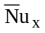 |  | 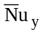
Ra | φ | Cianfrini et al. [9] | Present Result | Cianfrini et al. [9] | Present Result
10⁴ | -45° | 3.90 | 2.641518 | 5.80 | 4.551091
10⁴ | 0° | 4.05 | 2.805510 | 5.80 | 4.499424
10⁴ | 45° | 4.95 | 3.074480 | 4.95 | 3.074480
10⁵ | -45° | 4.40 | 3.272340 | 8.10 | 6.899918
10⁵ | 0° | 5.00 | 3.720636 | 8.10 | 6.736634
10⁵ | 45° | 4.95 | 3.660521 | 6.50 | 5.357398

